Traffic Sign Recognition Control Function – CGEA1.3

Functional Description

The Traffic Sign Recognition (TSR) feature is a mechanism for determining the “True” speed limit of the current vehicle path and displaying that information to the user. TSR relies on data transmitted by the Electronic Horizon (EH) feature, as well as data collected by a forward facing camera. The TSR application determines this environmental information and transmits this information to the cluster for display to the user.

There are two variants of the TSR feature
TSR Feature Overview
Variant Name | Variant Description | Remarks
SLOIF | Speed Limit and Overtaking Information Function  Full TSR functionality including:  - Displaying up to two speed limit signs incl. detailed supplementary signs and cancellation sign  (if available and supported in corresponding region)  - Displaying up to one no-passing sign incl. detailed supplementary signs and cancellation sign  (if available and supported in corresponding region)  - Over speed warning (optical/acoustical) | HMI Example:  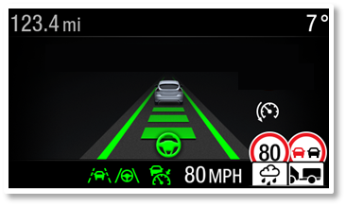
SLIF | Speed Limit Information Function  Reduced TSR functionality to support EuroNCAP functionalities:  - Displaying up to one speed limit sign incl. generic supplementary sign  - Optical over speed warning  (SLIF does not provide:  - Display no-passing signs  - Display detailed supplementary signs  - Acoustical over speed warning) | SLIF is sufficient for intelligent speed assist (ISA) and intelligent adaptive cruise control (iACC).  HMI Example:  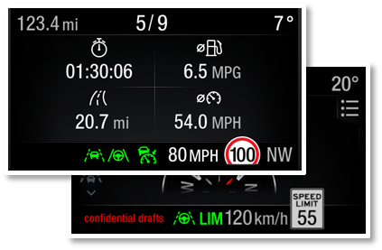

Note that even when the settings for this feature are displayed in the Center Stack, the cluster still provides warnings, chime, detailed and generic traffic sign indications for this feature.

The TSR control function correlates the Personalization signals, several signals from the IPMA module and the Operational_Mode to determine when to activate the appropriate displays.

This STSS is applicable on programs that are equipped with DAT2.0 ADAS domain controller. Programs with CADS3.5 IPMA shall continue to implement the “Traffic Sign Recognition Control Function – CGEA1.3” STSS.
Cluster D&R shall align with TSR application feature owner on STSS version.

Interfaces

Interface Context Diagram (I/O Block Diagram)
TSR Function Context Diagram

Inputs

IR-REQ-331925/A-Internal
- Operational_Mode
- M/C Switch Event
- Traffic Sign Recognition – EOL Feature Cfg
- SLIF_Cfg – EOL Feature Cfg
- Settings_Menu_Cfg – EOL Feature Cfg (Determines if settings are displayed in Cluster or CenterStack display)
- M/C_Display_Status
- Chime_Menu_Information_Status_Flag – Refer to “Chime Menu Control Function – CGEA1.3” STSS for the definition and usage of this variable.

MUX Signals on the CAN Bus from IPMA

SIG-REQ-331908/A-FeatConfigIpmaActl Signal

Signal Name | Size (bits) | Detail | Units | Res. | Offset | State Encoded | Min | Max
FeatConfigIpmaActl | 16 | - | Undefined | 1 | 0 |  | 0  (0x0) | 65535  (0xFFFF)

SIG-REQ-331909/A-FeatNoIpma_No_Actl Signal

Signal Name | Size (bits) | Detail | Units | Res. | Offset | State  Encoded | Min | Max
FeatNoIpmaActl | 16 | - | Number | 1 | 0 |  | 0  (0x0) | 65535  (0xFFFF)

SIG-REQ-331910/A-PersIndexIpma_D_Actl Signal

Signal Name | Size  (bits) | Detail | Units | Res. | Offset | State Encoded | Min | Max
PersIndexIpma_D_Actl | 3 |  | SED | 1 | 0 |  | 0 (0x0) | 7 (0x7)
 |  | PERS_1 |  |  |  | 0x0
 |  | PERS_2 |  |  |  | 0x1
 |  | PERS_3 |  |  |  | 0x2
 |  | PERS_4 |  |  |  | 0x3
 |  | Vehicle |  |  |  | 0x4
 |  | Unused |  |  |  | 0x5
 |  | Unused |  |  |  | 0x6
 |  | Unused |  |  |  | 0x7

SIG-REQ-331911/A-TsrVl1RstrcMsgTxt2_D_Rq Signal

Signal Name | Size  (bits) | Detail | Units | Res. | Offset | State Encoded | Min | Max
TsrVl1RstrcMsgTxt2_D_Rq | 3 |  | SED | 1 | 0 |  | 0  (0x0) | 7  (0x7)
 |  | Null |  |  |  | 0x0
 |  | NoSpeedLimitRestriction |  |  |  | 0x1
 |  | NoRecognizable  Restriction |  |  |  | 0x2
 |  | RainWet |  |  |  | 0x3
 |  | Snow |  |  |  | 0x4
 |  | Trailer |  |  |  | 0x5
 |  | Time |  |  |  | 0x6
 |  | NotUsed |  |  |  | 0x7

SIG-REQ-331912/A-TsrVl2RstrcMsgTxt2_D_Rq Signal

Signal Name | Size  (bits) | Detail | Units | Res. | Offset | State Encoded | Min | Max
TsrVl2RstrcMsgTxt2_D_Rq | 3 |  | SED | 1 | 0 |  | 0  (0x0) | 7  (0x7)
 |  | Null |  |  |  | 0x0
 |  | NoSpeedLimitRestriction |  |  |  | 0x1
 |  | NoRecognizableRestriction |  |  |  | 0x2
 |  | RainWet |  |  |  | 0x3
 |  | Snow |  |  |  | 0x4
 |  | Trailer |  |  |  | 0x5
 |  | Time |  |  |  | 0x6
 |  | NotUsed |  |  |  | 0x7

SIG-REQ-331913/A-TsrVl1StatMsgTxt_D_Rq Signal

Signal Name | Size  (bits) | Detail | Units | Res. | Offset | State Encoded | Min | Max
TsrVl1StatMsgTxt_D_Rq | 2 |  | SED | 1 | 0 |  | 0  (0x0) | 3  (0x3)
 |  | Null |  |  |  | 0x0
 |  | LimitChanged |  |  |  | 0x1
 |  | LimitReliable |  |  |  | 0x2
 |  | LimitOutdated |  |  |  | 0x3

SIG-REQ-331914/A-TsrVl2StatMsgTxt_D_Rq Signal

Signal Name | Size  (bits) | Detail | Units | Res. | Offset | State Encoded | Min | Max
TsrVl2StatMsgTxt_D_Rq | 2 |  | SED | 1 | 0 |  | 0  (0x0) | 3  (0x3)
 |  | Null |  |  |  | 0x0
 |  | LimitChanged |  |  |  | 0x1
 |  | LimitReliable |  |  |  | 0x2
 |  | LimitOutdated |  |  |  | 0x3

SIG-REQ-331915/A-TsrVlUnitMsgTxt_D_Rq Signal

Signal Name | Size  (bits) | Detail | Units | Res. | Offset | State Encoded | Min | Max
TsrVlUnitMsgTxt_D_Rq | 2 |  | SED | 1 | 0 |  | 0  (0x0) | 3  (0x3)
 |  | Null |  |  |  | 0x0
 |  | Kph |  |  |  | 0x1
 |  | Mph |  |  |  | 0x2
 |  | NoDataExists |  |  |  | 0x3

SIG-REQ-331916/A-TsrVl1PrmntMsgTxt_D_Rq Signal

Signal Name | Size  (bits) | Detail | Units | Res. | Offset | State Encoded | Min | Max
TsrVl1PrmntMsgTxt_D_Rq | 2 |  | SED | 1 | 0 |  | 0  (0x0) | 3  (0x3)
 |  | DoNotShowSignPermanent |  |  |  | 0x0
 |  | ShowPermanentlyWithoutSupp |  |  |  | 0x1
 |  | ShowPermanentlyWithSupp |  |  |  | 0x2
 |  | NotUsed |  |  |  | 0x3

SIG-REQ-331917/A-TsrVl2PrmntMsgTxt_D_Rq Signal

Signal Name | Size  (bits) | Detail | Units | Res. | Offset | State Encoded | Min | Max
TsrVl2PrmntMsgTxt_D_Rq | 2 |  | SED | 1 | 0 |  | 0  (0x0) | 3  (0x3)
 |  | DoNotShowSignPermanent |  |  |  | 0x0
 |  | ShowPermanentlyWithoutSupp |  |  |  | 0x1
 |  | ShowPermanentlyWithSupp |  |  |  | 0x2
 |  | NotUsed |  |  |  | 0x3

SIG-REQ-331918/A-TsrOvtkMsgTxt2_D_Rq Signal

Signal Name | Size  (bits) | Detail | Units | Res. | Offset | State Encoded | Min | Max
TsrOvtkMsgTxt2_D_Rq | 4 |  | SED | 1 | 0 |  | 0  (0x0) | 15  (0xF)
 |  | OvertakingAllowed |  |  |  | 0x0
 |  | LimAllWithoutRestriction |  |  |  | 0x1
 |  | LimAllWithoutQlfdRstrc |  |  |  | 0x2
 |  | LimAllWithRstrcRain |  |  |  | 0x3
 |  | LimAllWithRstrcSnow |  |  |  | 0x4
 |  | LimAllWithRstrcTrailer |  |  |  | 0x5
 |  | LimAllWithRstrcTime |  |  |  | 0x6
 |  | LimAllCancelled |  |  |  | 0x7
 |  | LimForTrucksWithoutRstrc |  |  |  | 0x8
 |  | LimForTrucksWoQlfdRstrc |  |  |  | 0x9
 |  | LimForTrucksCancelled |  |  |  | 0xA
 |  | NotUsed1 |  |  |  | 0xB
 |  | NotUsed2 |  |  |  | 0xC
 |  | NotUsed3 |  |  |  | 0xD
 |  | NotUsed4 |  |  |  | 0xE
 |  | NotUsed5 |  |  |  | 0xF

SIG-REQ-331919/A-TsrOvtkMsgTxt_D_Rq Signal

Signal Name | Size  (bits) | Detail | Units | Res. | Offset | State Encoded | Min | Max
TsrOvtkMsgTxt_D_Rq | 3 |  | SED | 1 | 0 |  | 0  (0x0) | 7  (0x7)
 |  | Null |  |  |  | 0x0
 |  | OvertakingAllowed |  |  |  | 0x1
 |  | LimAllWithoutRestriction |  |  |  | 0x2
 |  | LimAllWithoutQlfdRstrc |  |  |  | 0x3
 |  | LimAllCancelled |  |  |  | 0x4
 |  | LimForTrucksWithoutRstrc |  |  |  | 0x5
 |  | LimForTrucksWoQlfdRstrc |  |  |  | 0x6
 |  | LimForTrucksCancelled |  |  |  | 0x7

SIG-REQ-331920/A-TsrOvtkStatMsgTxt_D_Rq Signal

Signal Name | Size  (bits) | Detail | Units | Res. | Offset | State Encoded | Min | Max
TsrOvtkStatMsgTxt_D_Rq | 2 |  | SED | 1 | 0 |  | 0  (0x0) | 3  (0x3)
 |  | Null |  |  |  | 0x0
 |  | LimitChanged |  |  |  | 0x1
 |  | LimitReliable |  |  |  | 0x2
 |  | LimitOutdated |  |  |  | 0x3

SIG-REQ-331921/A-TsrVLim1MsgTxt_D_Rq Signal

Signal Name | Size (bits) | Detail | Units | Res. | Offset | State Encoded | Min | Max
TsrVLim1MsgTxt_D_Rq | 8 |  | SED | 1 | 0 |  | 0  (0x0) | 255  (0xFF)
 |  | Null |  |  |  | 0 (0x0)
 |  | Message1 |  |  |  | 1 (0x1)
 |  | Message2 |  |  |  | 2 (0x2)
 |  | Message3 |  |  |  | 3 (0x3)
 |  | Message4 |  |  |  | 4 (0x4)
 |  | Message5 |  |  |  | 5 (0x5)
 |  | Message6 |  |  |  | 6 (0x6)
 |  | Message7 |  |  |  | 7 (0x7)
 |  | Message8 |  |  |  | 8 (0x8)
 |  | Message9 |  |  |  | 9 (0x9)
 |  | Message0 |  |  |  | 10 (0xA)
 |  | Message11 |  |  |  | 11 (0xB)
 |  | Message12 |  |  |  | 12 (0xC)
 |  | Message13 |  |  |  | 13 (0xD)
 |  | Message14 |  |  |  | 14 (0xE)
 |  | Message15 |  |  |  | 15 (0xF)
 |  | Message16 |  |  |  | 16 (0x10)
 |  | Message17 |  |  |  | 17 (0x11)
 |  | Message18 |  |  |  | 18 (0x12)
 |  | Message19 |  |  |  | 19 (0x13)
 |  | Message20 |  |  |  | 20 (0x14)
 |  | Message21 |  |  |  | 21 (0x15)
 |  | Message22 |  |  |  | 22 (0x16)
 |  | Message23 |  |  |  | 23 (0x17)
 |  | Message24 |  |  |  | 24 (0x18)
 |  | Message25 |  |  |  | 25 (0x19)
 |  | Message26 |  |  |  | 26 (0x1A)
 |  | Message27 |  |  |  | 27 (0x1B)
 |  | Message28 |  |  |  | 28 (0x1C)
 |  | Message29 |  |  |  | 29 (0x1D)
 |  | Message30 |  |  |  | 30 (0x1E)
 |  | … |  |  |  | …
 |  | Message250 |  |  |  | 250 (0xFA)
 |  | LimitCancelled |  |  |  | 251 (0xFB)
 |  | NotToBeDisplayed |  |  |  | 252 (0xFC)
 |  | NotUsed |  |  |  | 253, 254 (0xFD, 0xFE)
 |  | NoLimit |  |  |  | 255 (0xFF)

SIG-REQ-331922/A-TsrVLim2MsgTxt_D_Rq Signal

Signal Name | Size (bits) | Detail | Units | Res. | Offset | State Encoded | Min | Max
TsrVLim2MsgTxt_D_Rq | 8 |  | SED | 1 | 0 |  | 0  (0x0) | 255  (0xFF)
 |  | Null |  |  |  | 0 (0x0)
 |  | Message1 |  |  |  | 1 (0x1)
 |  | Message2 |  |  |  | 2 (0x2)
 |  | Message3 |  |  |  | 3 (0x3)
 |  | Message4 |  |  |  | 4 (0x4)
 |  | Message5 |  |  |  | 5 (0x5)
 |  | Message6 |  |  |  | 6 (0x6)
 |  | Message7 |  |  |  | 7 (0x7)
 |  | Message8 |  |  |  | 8 (0x8)
 |  | Message9 |  |  |  | 9 (0x9)
 |  | Message10 |  |  |  | 10 (0xA)
 |  | Message11 |  |  |  | 11 (0xB)
 |  | Message12 |  |  |  | 12 (0xC)
 |  | Message13 |  |  |  | 13 (0xD)
 |  | Message14 |  |  |  | 14 (0xE)
 |  | Message15 |  |  |  | 15 (0xF)
 |  | Message16 |  |  |  | 16 (0x10)
 |  | Message17 |  |  |  | 17 (0x11)
 |  | Message18 |  |  |  | 18 (0x12)
 |  | Message19 |  |  |  | 19 (0x13)
 |  | Message20 |  |  |  | 20 (0x14)
 |  | Message21 |  |  |  | 21 (0x15)
 |  | Message22 |  |  |  | 22 (0x16)
 |  | Message23 |  |  |  | 23 (0x17)
 |  | Message24 |  |  |  | 24 (0x18)
 |  | Message25 |  |  |  | 25 (0x19)
 |  | Message26 |  |  |  | 26 (0x1A)
 |  | Message27 |  |  |  | 27 (0x1B)
 |  | Message28 |  |  |  | 28 (0x1C)
 |  | Message29 |  |  |  | 29 (0x1D)
 |  | Message30 |  |  |  | 30 (0x1E)
 |  | … |  |  |  | …
 |  | Message250 |  |  |  | 250 (0xFA)
 |  | LimitCancelled |  |  |  | 251 (0xFB)
 |  | NotToBeDisplayed |  |  |  | 252 (0xFC)
 |  | NotUsed |  |  |  | 253, 254 (0xFD, 0xFE)
 |  | NoLimit |  |  |  | 255 (0xFF)

SIG-REQ-331923/A-TsrOswWarnMsgTxt_D_Rq Signal

Signal Name | Size (bits) | Detail | Units | Res. | Offset | State Encoded | Min | Max
TsrOswWarnMsgTxt_D_Rq | 2 |  | SED | 1 | 0 |  | 0  (0x0) | 3  (0x3)
 |  | Null |  |  |  | 0 (0x0)
 |  | False |  |  |  | 1 (0x1)
 |  | True |  |  |  | 2 (0x2)
 |  | NotUsed |  |  |  | 3 (0x3)

SIG-REQ-331924/A-TsrRegionTxt_D_StatSignal

Signal Name | Size (bits) | Detail | Units | Res. | Offset | State Encoded | Min | Max
TsrRegionStat_D_Stat | 5 |  | SED | 1 | 0 |  | 0  (0x0) | 31  (0x1F)
 |  | NotDetermined |  |  |  | 0 (0x0)
 |  | Region_01 |  |  |  | 1 (0x1)
 |  | Region_02 |  |  |  | 2 (0x2)
 |  | Region_03 |  |  |  | 3 (0x3)
 |  | Region_04 |  |  |  | 4 (0x4)
 |  | Region_05 |  |  |  | 5 (0x5)
 |  | Region_06 |  |  |  | 6 (0x6)
 |  | Region_07 |  |  |  | 7 (0x7)
 |  | Region_08 |  |  |  | 8 (0x8)
 |  | Region_09 |  |  |  | 9 (0x9)
 |  | Region_10 |  |  |  | 10 (0xA)
 |  | Region_11 |  |  |  | 11 (0xB)
 |  | Region_12 |  |  |  | 12 (0xC)
 |  | Region_13 |  |  |  | 13 (0xD)
 |  | Region_14 |  |  |  | 14 (0xE)
 |  | Region_15 |  |  |  | 15 (0xF)
 |  | Region_16 |  |  |  | 16 (0x10)
 |  | Region_17 |  |  |  | 17 (0x11)
 |  | Region_18 |  |  |  | 18 (0x12)
 |  | Region_19 |  |  |  | 19 (0x13)
 |  | Region_20 |  |  |  | 20 (0x14)
 |  | Region_21 |  |  |  | 21 (0x15)
 |  | Region_22 |  |  |  | 22 (0x16)
 |  | NotUsed_1 – NotUsed_08 |  |  |  | 23 (0x17) –  30 (0x1E)
 |  | Faulty |  |  |  | 31 (0x1F)

SIG-REQ-402302/A-RoadSignRgltry_D_Dsply Signal

Signal Name | Size (bits) | Detail | Units | Res. | Offset | State Encoded | Min | Max
RoadSignRgltry_D_Dsply | 2 |  | SED | 1 | 0 |  | 0  (0x0) | 3  (0x3)
RoadSignRgltry_D_Dsply |  | None |  |  |  | 0x0
RoadSignRgltry_D_Dsply |  | Yield |  |  |  | 0x1
RoadSignRgltry_D_Dsply |  | Stop |  |  |  | 0x2
RoadSignRgltry_D_Dsply |  | NoEntry |  |  |  | 0x3

Outputs

IR-REQ-331798/B-Internal

Name | Description | Example / Reference
TSR_OSW_SETUP_MC | Output controls setting menu display output for TSR Overspeed Warning Setup.
TSR_OSW_TOLERANCE_MC | Output controls setting menu display output for TSR Overspeed Tolerance | 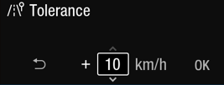
TSR_Speed_Limit_1_Detail_MC | Output displays detailed graphics pertaining to TSR Speed Limit 1 | 
TSR_Speed_Limit_1_Generic_MC | Output displays generic graphics pertaining to TSR Speed Limit 1 | 
TSR_Speed_Limit_2_Detail_MC | Output displays detailed graphics pertaining to TSR Speed Limit 2 | 
TSR_Speed_Limit_2_Generic_MC | Output displays generic graphics pertaining to TSR Speed Limit 2 | 
TSR_No_Passing_Detail_Ind_MC | Output displays different graphics pertaining to detailed TSR No Passing information. | 
TSR_No_Passing_Generic_Ind_MC | Output displays status of generic TSR No Passing Information | 
TSR_Osw_Chime_Status_Flag | Output chime flag for TSR overspeed chime. | n/a
TSR_Road_Sign_Display_MC | Output displays status of road sign display. | 

MUX Signals on the CAN bus

SIG-REQ-331926/A-MsgCntrDsplyOp_D_Rq Signal

Signal Name | Size (bits) | Detail | Units | Res. | Offset | State Encoded | Min | Max
MsgCntrDsplyOp_D_Rq | 3 |  | SED | 1 | 0 |  | 0  (0x0) | 7  (0x7)
 |  | NULL |  |  |  | 0x0
 |  | QUERY |  |  |  | 0x1
 |  | SET |  |  |  | 0x2
 |  | UPLOAD |  |  |  | 0x3
 |  | RESTORE |  |  |  | 0x4
 |  | COPY |  |  |  | 0x5
 |  | Unused |  |  |  | 0x6
 |  | Unused |  |  |  | 0x7
.

SIG-REQ-331927/A-MsgCntrFeatConfigRq Signal

Signal Name | Size (bits) | Detail | Units | Res. | Offset | State  Encoded | Min | Max
MsgCntrFeatConfigRq | 16 |  | Undefined | 1 | 0 |  | 0  (0x0) | 65535  (0xFFFF)

SIG-REQ-331928/A-MsgCntrFeatNoRq Signal

Signal Name | Size (bits) | Detail | Units | Res. | Offset | State  Encoded | Min | Max
MsgCntrFeatNoRq | 16 |  | Number | 1 | 0 |  | 0  (0x0) | 65535  (0xFFFF)

SIG-REQ-331929/B-MsgCntrPersIndex_D_Rq Signal

Signal Name | Size (bits) | Detail | Units | Res. | Offset | State Encoded | Min | Max
MsgCntrPersIndex_D_Rq | 3 |  | SED | 1 | 0 |  | 0  (0x0) | 7  (0x7)
 |  | PERS_1 |  |  |  | 0x0
 |  | PERS_2 |  |  |  | 0x1
 |  | PERS_3 |  |  |  | 0x2
 |  | PERS_4 |  |  |  | 0x3
 |  | Vehicle |  |  |  | 0x4
 |  | Unused |  |  |  | 0x5
 |  | Unused |  |  |  | 0x6
 |  | Unused |  |  |  | 0x7

Function/Performance

F-REQ-331930/A-Operational Modes

Mode | Differentiating Vehicle Conditions
Sleep Mode | TSR Display Messages Disabled
Limited Mode | TSR Display Messages Disabled
Normal Mode | TSR Display Messages Enabled / Disabled - ability to change the TSR settings
Crank Mode | TSR Display Messages Enabled / Disabled - ability to change the TSR settings

Voltage Levels

Refer to the Cluster Features table located in the Operational Modes and Voltage Range Strategies Section in this SPSS.

Human-Machine Interface

Visual
In SLOIF variant, up to two traffic signs can be displayed in two locations.
- The primary speed limit shall be displayed in the first location. (Speed Limit 1)
  - Input signal related to the primary speed limit:
    - TsrVl1PrmntMsgTxt_D_Rq, TsrVl1StatMsgTxt_D_Rq, TsrVl1RstrcMsgTxt2_D_Rq, TsrVLim1MsgTxt_D_Rq
  - The secondary speed limit and the no-passing sign shall be displayed in the second location (Speed Limit 2 / No Passing Info)
    - Input signals related to the secondary speed limit:
      - TsrVl2PrmntMsgTxt_D_Rq, TsrVl2StatMsgTxt_D_Rq, TsrVl2RstrcMsgTxt2_D_Rq, TsrVLim2MsgTxt_D_Rq
    - Input signals related to the No-passing sign:
      - TsrOvtkMsgTxt2_D_Rq, TsrOvtkMsgTxt_D_Rq, TsrOvtkStatMsgTxt_D_Rq
    - In case valid no-passing sign and secondary speed limit information is received, nothing shall be displayed.
- If no traffic sign is being displayed, one blank placeholder shall be displayed
- .Note: The IPMA (control module) will avoid conflicts between the secondary speed limit information and no-passing sign display by transmitting the appropriate states over the input signals. The cluster shall simply display the information based on these inputs.
  - Example:
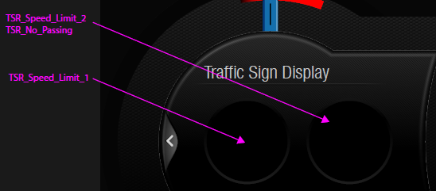 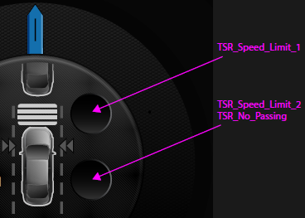

- Traffic signs are displayed with either detailed or generic supplementary signs. Whether generic or detailed are to be displayed is defined by the program specific HMI. TSR variant SLIF supports generic display of speed limit 1 only.

Examples:
Examples for generic display | Examples for detailed display
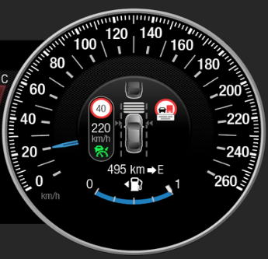 | 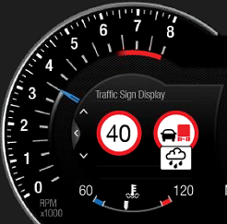
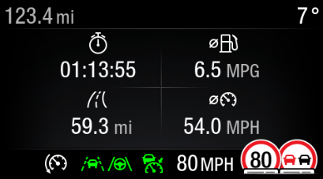 | 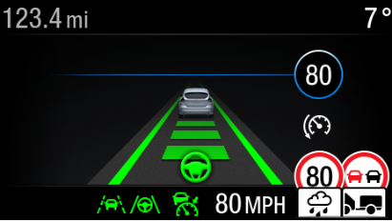
n/a | 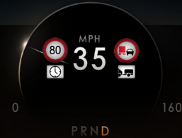
n/a | 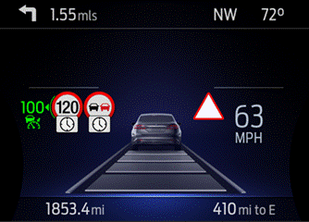

Indicator Graphics / Display Format
Please refer to the program specific menu structure for exact graphics.

Example Menu Structure:

Menu level 0 | Menu level 1 | Menu level 2 | Menu level 3
Driver Assist | Speed Limits | Speed Warning
Driver Assist | Speed Limits | Limiter with Speed Signs
Driver Assist | Speed Limits | Tolerance | Speed Warning Tolerance (Scrolling Numbers)
Note: “Limiter with Speed Signs” is not part of this STSS, it is simply shown since it’s part of the menu. This variable is defined in the ISA STSS

Indicator Color Coordinates

Refer to program specific HMI requirements for styling direction.

Indicator Characteristics

As per program specific HMI theme.

Audio

As per F-REQ-331943

Switch Control Logic

Consumer access to the Traffic Sign Recognition Configuration shall be as specified in the message center basic functionality display as specified in Message Center X Display_Y Button Interface Section, where X and Y are appropriate values in this document.

PFM-REQ-331950/A-System Accuracy
Within a 100msec of receiving a message that results in a change of state the cluster will update the display to the proper status.

Operation: Performance and Functional

Subsystem Algorithm Flowchart / State Diagram

F-REQ-331802/A-Traffic Sign Recognition Diagnostic Configuration Flowchart

User Setup

F-REQ-331801/A-TSR Input Request Flowchart

F-REQ-331805/A-TSR output SET request Flowchart

F-REQ-331931/A-TSR Overspeed Warning Setup State Assignment

FeatNoIpmaActl Signal | FeatConfigIpmaActl Signal |  | PersIndexIpma_D_Actl Signal |  | TSR_OSW_  SETUP_MC |  | Current_PERS ⁽³⁾
0x080D ⁽¹⁾ |  | 0x0000 (Off) |  | 0x0 – 0x4 |  | 0x00 |  | 0x0 – 0x4
 |  | 0x0001 (On) |  | 0x0 – 0x4 |  | 0x01 |  | 0x0 – 0x4
 |  | Other ⁽²⁾ |  |  |  | Error  (0x2) |  | Last Known
Missing per Section 1.4.1 ⁽²⁾
⁽¹⁾ TSR Overspeed Warning Setup Feature Number. Reference is Feat Num table in “Vehicle Personalization FS”
⁽²⁾ Message Response is Faulted
⁽³⁾ Equal to the received “PersIndex<--->” signal value. When faulted Keep last known value.

F-REQ-331932/A-TSR Overspeed Warning Setup Request Messages based upon TSR_OSW_SETUP_MC

TSR_OSW_  SETUP_MC | Display Menu | M/C Switch Selection Event | MsgCntrDsplyOp_  D_Rq Signal | MsgCntrFeatNoRq  Signal | MsgCntrFeatConfigRq  Signal | MsgCntrPersIndex_D_Rq Signal
0x00 |  | Up/Down + OK (Select On) | SET (0x2) | 0x080D | 0x0001  (On is selected) | Current_PERS
0x01 |  | Up/Down + OK (Select Off) | SET (0x2) | 0x080D | 0x0000  (If Off is selected) | Current_PERS
0x02 |  | Up/Down + OK (Select Any) | SET (0x2) | 0x080D | 0x0000 (If On is selected)  0x0001 (If Off is selected) | Current_PERS
Note: TSR_Cfg or SLIF_Cfg must be set to Enabled (0x1) to display this menu

F-REQ-331933/A-TSR Overspeed Warning Threshold Setup State Assignment

FeatNoIpmaActl Signal | FeatConfigIpmaActl Signal |  | PersIndexIpma_D_Actl Signal |  | TSR_OSW_  THRESHOLD_MC | Current_PERS ⁽³⁾
0x080E ⁽¹⁾ |  | 0x0000 – 0x000F (Inactive) |  | 0x0 – 0x4 | 0x00 | 0x0 – 0x4
 |  | 0x0010 – 0x001A (valid speed thresholds in Metric units)  0x0010 – 0x0015 (valid speed thresholds in English units) |  | 0x0 – 0x4 | 0x00 – 0x0A (for Metric units)  0x00 – 0x05 (for English units) | 0x0 – 0x4
 |  | Other ⁽²⁾ |  |  | 0x00  (Display 0) | Last Known
Missing per Section 1.4.1 ⁽²⁾ |  |  |  |  | 0x00  (Display 0)
⁽¹⁾ TSR Overspeed Warning Threshold Setup Feature Number. Reference is Feat Num table in “Vehicle Personalization FS”
⁽²⁾ Message Response is Faulted
⁽³⁾ Equal to the received “PersIndex<--->” signal value. When faulted Keep last known value.

F-REQ-331934/A-TSR Overspeed Warning Threshold Setup Request Messages based upon TSR_OSW_THRESHOLD_MC

TSR_OSW_SETUP  _MC | TSR_OSW_  THRESHOLD_MC | Display Menu | M/C Switch Selection Event | MsgCntrDsplyOp_D_Rq  Signal | MsgCntrFeatNoRq  Signal | MsgCntrFeatConfigRq  Signal | MsgCntrPersIndex_D_Rq  Signal
0x01  (Enabled) | 0x00 | 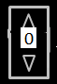 | Based on HMI direction (Select Any valid value) | SET (0x2) | 0x080E | 0x11 – 0x1A ( If any valid speed threshold is selected in metric units)  0x0011 – 0x15 (If any valid speed threshold is selected in English units) | Current_PERS
0x01  (Enabled) | 0x01 | 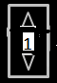 | Based on HMI direction (Select Any valid value) | SET (0x2) | 0x080E | 0x10 – 0x1A (If any valid speed threshold is selected in metric units)  0x10 – 0x15 (If any valid speed threshold is selected in English units) | Current_PERS
0x01  (Enabled) | …. | …. | Based on HMI direction (Select Any valid value) | SET (0x2) | 0x080E | 0x10 – 0x1A (If any valid speed threshold is selected in metric units)  0x10 – 0x15 (If any valid speed threshold is selected in English units) | Current_PERS
0x01  (Enabled) | 0x0A (for metric units)  0x05 (for English units) |    | Based on HMI direction (Select Any valid value) | SET (0x2) | 0x080E | 0x10 – 0x19 (If any valid speed threshold is selected in metric units)  0x10 – 0x14 (If any valid speed threshold is selected in English units) | Current_PERS
Note: TSR_OSW_SETUP_MC must be Enabled (0x1) to display this menu.
Note: The over speed threshold values in the Display Menu above are in 1 unit increments.
Note: The graphics shown under the “Display Menu” column are shown as examples.
Note: The display of the scrolling numbers of the over speed warning shall be limited to the values between 0 - 10 kph and 0 - 5 mph.

F-REQ-331806/A-TSR Overspeed Threshold Unit Determination Flowchart

TSR Speed Limit 1 Display

F-REQ-331808/B-TSR Speed Limit 1 Information Display PreConditions

Notes:
- The graphics shown below are for example purposes only. Please refer to program specific display menu and/or graphics library for accurate graphics.
- The value in the circle of the RTT shall be replaced by the value received in the TsrVLim1MsgTxt_D_Rq input signal.
- Speed Limit 1 shall be displayed in the first location. Exact display locations determined by product specific HMI logic.
- North American HMI applies for SLIF only, hence it is not applicable for detailed display of speed limit 1 TSR_Speed_Limit_1_Detail_MC).

F-REQ-331935/C-State Matrix for TSR_Speed_Limit_1_Generic_MC

 |  |  | TSR_Speed_Limit_1_Generic_MC
TsrVLim1MsgTxt_D_Rq Signal | TsrVl1StatMsgTxt_D_Rq Signal | TsrVl1PrmntMsgTxt_D_Rq Signal | TsrRegionTxt_D_Stat
TsrVLim1MsgTxt_D_Rq Signal | TsrVl1StatMsgTxt_D_Rq Signal | TsrVl1PrmntMsgTxt_D_Rq Signal | <> Region_03 | Region_03
<> (0x00, 0xFB, 0xFC, 0xFD, 0xFE, 0xFF) | LimitChanged (0x1) | ShowPermanentlyWithoutSupp  (0x1) |  | 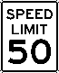
<> (0x00, 0xFB, 0xFC, 0xFD, 0xFE, 0xFF) | LimitChanged (0x1) | ShowPermanentlyWithSupp  (0x2) | 
<> (0x00, 0xFB, 0xFC, 0xFD, 0xFE, 0xFF) | LimitReliable (0x2) | ShowPermanentlyWithoutSupp  (0x1) |  | 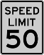
<> (0x00, 0xFB, 0xFC, 0xFD, 0xFE, 0xFF) | LimitReliable (0x2) | ShowPermanentlyWithSupp  (0x2) | 
<> (0x00, 0xFB, 0xFC, 0xFD, 0xFE, 0xFF) | LimitOutdated (0x3) | ShowPermanentlyWithoutSupp  (0x1) | 
<> (0x00, 0xFB, 0xFC, 0xFD, 0xFE, 0xFF) | LimitOutdated (0x3) | ShowPermanentlyWithSupp  (0x2) | 
LimitCancelled (0xFB) | LimitChanged (0x1) | X |  | 
LimitCancelled (0xFB) | LimitReliable (0x2) ||  LimitOutdated (0x3) | X
NoLimit (0xFF) | X | X | 
NotToBeDisplayed (0xFC) | X | X | No placeholder displayed  (nothing displayed for TSR)
All Other Cases |  |  | No placeholder displayed  (nothing displayed for TSR)
Note: If no speed limit is to be displayed (TsrVLim1MsgTxt_D_Rq == 0xFF), a blank placeholder shall be displayed.

F-REQ-331936/C-State Matrix for TSR_Speed_Limit_1_Detail_MC

TsrVLim1MsgTxt_D_Rq Signal | TsrVl1StatMsgTxt_D_Rq Signal | TsrVl1RstrcMsgTxt2_D_Rq | TSR_Speed_Limit_1_Detail_MC
<> (0x00, 0xFB, 0xFC, 0xFD, 0xFE, 0xFF) | LimitChanged (0x1) | NoSpeedLimitRestriction (0x1)
<> (0x00, 0xFB, 0xFC, 0xFD, 0xFE, 0xFF) | LimitChanged (0x1) | NoRecognizableRestrctn (0x2) | 
<> (0x00, 0xFB, 0xFC, 0xFD, 0xFE, 0xFF) | LimitChanged (0x1) | RainWet (0x3) | 
<> (0x00, 0xFB, 0xFC, 0xFD, 0xFE, 0xFF) | LimitChanged (0x1) | Snow (0x4) | 
<> (0x00, 0xFB, 0xFC, 0xFD, 0xFE, 0xFF) | LimitChanged (0x1) | Trailer (0x5) | 
<> (0x00, 0xFB, 0xFC, 0xFD, 0xFE, 0xFF) | LimitChanged (0x1) | Time (0x6) | 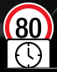
<> (0x00, 0xFB, 0xFC, 0xFD, 0xFE, 0xFF) | LimitReliable (0x2) | NoSpeedLimitRestriction (0x1)
<> (0x00, 0xFB, 0xFC, 0xFD, 0xFE, 0xFF) | LimitReliable (0x2) | NoRecognizableRestrctn (0x2) | 
<> (0x00, 0xFB, 0xFC, 0xFD, 0xFE, 0xFF) | LimitReliable (0x2) | RainWet (0x3) | 
<> (0x00, 0xFB, 0xFC, 0xFD, 0xFE, 0xFF) | LimitReliable (0x2) | Snow (0x4) | 
<> (0x00, 0xFB, 0xFC, 0xFD, 0xFE, 0xFF) | LimitReliable (0x2) | Trailer (0x5) | 
<> (0x00, 0xFB, 0xFC, 0xFD, 0xFE, 0xFF) | LimitReliable (0x2) | Time (0x6) | 
<> (0x00, 0xFB, 0xFC, 0xFD, 0xFE, 0xFF) | LimitOutdated (0x3) | NoSpeedLimitRestriction (0x1)
<> (0x00, 0xFB, 0xFC, 0xFD, 0xFE, 0xFF) | LimitOutdated (0x3) | NoRecognizableRestrctn (0x2) | 
<> (0x00, 0xFB, 0xFC, 0xFD, 0xFE, 0xFF) | LimitOutdated (0x3) | RainWet (0x3) | 
<> (0x00, 0xFB, 0xFC, 0xFD, 0xFE, 0xFF) | LimitOutdated (0x3) | Snow (0x4) | 
<> (0x00, 0xFB, 0xFC, 0xFD, 0xFE, 0xFF) | LimitOutdated (0x3) | Trailer (0x5) | 
<> (0x00, 0xFB, 0xFC, 0xFD, 0xFE, 0xFF) | LimitOutdated (0x3) | Time (0x6) | 
LimitCancelled (0xFB) | LimitChanged (0x1) | X
LimitCancelled (0xFB) | LimitReliable (0x2) ||  LimitOutdated (0x3) | X
NoLimit (0xFF) | X | X
NotToBeDisplayed (0xFC) | X | X | No placeholder displayed  (nothing displayed for TSR)
All Other Cases |  |  | No placeholder displayed  (nothing displayed for TSR)
Note:
- If no speed limit is to be displayed (TsrVLim1MsgTxt_D_Rq == 0xFF), a blank placeholder shall be displayed.
- North American HMI is not applicable for SLOIF.

TSR Speed Limit 2 Display

F-REQ-331811/B-TSR Speed Limit 2 Display Preconditions

F-REQ-331937/B-State Matrix and for TSR_Speed_Limit_2_Generic_MC

TsrVLim2MsgTxt_D_Rq Signal | TsrVl2StatMsgTxt_D_Rq Signal | TsrVl2PrmntMsgTxt_D_Rq Signal | TSR_Speed_Limit_2_  Generic_MC
<> (0x00, 0xFB, 0xFC, 0xFD, 0xFE, 0xFF) | LimitChanged (0x1) | ShowPermanentlyWithoutSupp  (0x1)
<> (0x00, 0xFB, 0xFC, 0xFD, 0xFE, 0xFF) | LimitChanged (0x1) | ShowPermanentlyWithSupp  (0x2)
<> (0x00, 0xFB, 0xFC, 0xFD, 0xFE, 0xFF) | LimitReliable (0x2) | ShowPermanentlyWithoutSupp  (0x1)
<> (0x00, 0xFB, 0xFC, 0xFD, 0xFE, 0xFF) | LimitReliable (0x2) | ShowPermanentlyWithSupp  (0x2)
<> (0x00, 0xFB, 0xFC, 0xFD, 0xFE, 0xFF) | LimitOutdated (0x3) | ShowPermanentlyWithoutSupp  (0x1)
<> (0x00, 0xFB, 0xFC, 0xFD, 0xFE, 0xFF) | LimitOutdated (0x3) | ShowPermanentlyWithSupp  (0x2)
LimitCancelled (0xFB) | LimitChanged (0x1) | X
LimitCancelled (0xFB) | LimitReliable (0x2) ||  LimitOutdated (0x3) | X
All Other Cases |  |  | No placeholder displayed  (nothing displayed for TSR)

F-REQ-331938/B-State Matrix for TSR_Speed_Limit_2_Detailed_MC

TsrVLim2MsgTxt_D_Rq Signal | TsrVl2StatMsgTxt_D_Rq Signal | TsrVl2RstrcMsgTxt2_D_Rq | TSR_Speed_Limit_2_Detail_MC
<> (0x00, 0xFB, 0xFC, 0xFD, 0xFE, 0xFF) | LimitChanged (0x1) | NoSpeedLimitRestriction (0x1)
<> (0x00, 0xFB, 0xFC, 0xFD, 0xFE, 0xFF) | LimitChanged (0x1) | NoRecognizableRestrctn (0x2)
<> (0x00, 0xFB, 0xFC, 0xFD, 0xFE, 0xFF) | LimitChanged (0x1) | RainWet (0x3)
<> (0x00, 0xFB, 0xFC, 0xFD, 0xFE, 0xFF) | LimitChanged (0x1) | Snow (0x4)
<> (0x00, 0xFB, 0xFC, 0xFD, 0xFE, 0xFF) | LimitChanged (0x1) | Trailer (0x5)
<> (0x00, 0xFB, 0xFC, 0xFD, 0xFE, 0xFF) | LimitChanged (0x1) | Time (0x6)
<> (0x00, 0xFB, 0xFC, 0xFD, 0xFE, 0xFF) | LimitReliable (0x2) | NoSpeedLimitRestriction (0x1)
<> (0x00, 0xFB, 0xFC, 0xFD, 0xFE, 0xFF) | LimitReliable (0x2) | NoRecognizableRestrctn (0x2)
<> (0x00, 0xFB, 0xFC, 0xFD, 0xFE, 0xFF) | LimitReliable (0x2) | RainWet (0x3)
<> (0x00, 0xFB, 0xFC, 0xFD, 0xFE, 0xFF) | LimitReliable (0x2) | Snow (0x4)
<> (0x00, 0xFB, 0xFC, 0xFD, 0xFE, 0xFF) | LimitReliable (0x2) | Trailer (0x5)
<> (0x00, 0xFB, 0xFC, 0xFD, 0xFE, 0xFF) | LimitReliable (0x2) | Time (0x6)
<> (0x00, 0xFB, 0xFC, 0xFD, 0xFE, 0xFF) | LimitOutdated (0x3) | NoSpeedLimitRestriction (0x1)
<> (0x00, 0xFB, 0xFC, 0xFD, 0xFE, 0xFF) | LimitOutdated (0x3) | NoRecognizableRestrctn (0x2)
<> (0x00, 0xFB, 0xFC, 0xFD, 0xFE, 0xFF) | LimitOutdated (0x3) | RainWet (0x3)
<> (0x00, 0xFB, 0xFC, 0xFD, 0xFE, 0xFF) | LimitOutdated (0x3) | Snow (0x4)
<> (0x00, 0xFB, 0xFC, 0xFD, 0xFE, 0xFF) | LimitOutdated (0x3) | Trailer (0x5)
<> (0x00, 0xFB, 0xFC, 0xFD, 0xFE, 0xFF) | LimitOutdated (0x3) | Time (0x6)
LimitCancelled (0xFB) | LimitChanged (0x1) | X
LimitCancelled (0xFB) | LimitReliable (0x2) ||  LimitOutdated (0x3) | X
All Other Cases |  |  | No placeholder displayed  (nothing displayed for TSR)

TSR No-Passing Restriction Display

F-REQ-331813/B-TSR No-Passing Restriction Display Preconditions
Notes:
- The graphics shown below are for example purposes only. Please refer to program specific display menu and/or graphics library for accurate graphics.
- No-Passing restriction shall be displayed in the second location. Exact display locations determined by product specific HMI logic.
- No passing graphics are relevant in SLOIF (full TSR) mode only.
- If no no-passing restriction is to be displayed, nothing shall be displayed.

F-REQ-331939/A-State Matrix for TSR_No_Passing_Generic_Ind_MC

 |  |  |  | TSR_No_Passing_Generic_Ind_MC
TsrOvtkStatMsgTxt_D_Rq Signal | TsrOvtkMsgTxt_D_Rq  Signal |  | TsrRegionTxt_D_Stat
TsrOvtkStatMsgTxt_D_Rq Signal |  |  | X |  | Region_02 (0x2) | Region_04 (0x4) | Region_05 (0x5)
LimitChanged (0x1) | LimAllWithoutRestriction  (0x2) |  |  |  |  |  | 
LimitChanged (0x1) | LimAllWithoutQlfdRstrc  (0x3) |  |  |  |  |  | 
LimitChanged (0x1) | LimAllCancelled  (0x4) |  |  |  |  | 
LimitChanged (0x1) | LimForTrucksWithoutRstrc  (0x5)
LimitChanged (0x1) | LimForTrucksWoQlfdRstrc  (0x6)
LimitChanged (0x1) | LimForTrucksCancelled  (0x7)
LimitReliable (0x2) | LimAllWithoutRestriction  (0x2) |  |  |  |  |  | 
LimitReliable (0x2) | LimAllWithoutQlfdRstrc  (0x3) |  |  |  |  |  | 
LimitReliable (0x2) | LimAllCancelled  (0x4) |  |  |  |  | 
LimitReliable (0x2) | LimForTrucksWithoutRstrc  (0x5)
LimitReliable (0x2) | LimForTrucksWoQlfdRstrc  (0x6)
LimitReliable (0x2) | LimForTrucksCancelled  (0x7)
LimitOutdated (0x3) | LimAllWithoutRestriction  (0x2) |  |  |  |  |  | 
LimitOutdated (0x3) | LimAllWithoutQlfdRstrc  (0x3) |  |  |  |  |  | 
LimitOutdated (0x3) | LimAllCancelled  (0x4)
LimitOutdated (0x3) | LimForTrucksWithoutRstrc  (0x5)
LimitOutdated (0x3) | LimForTrucksWoQlfdRstrc  (0x6)
LimitOutdated (0x3) | LimForTrucksCancelled  (0x7)

F-REQ-331940/B-State Matrix for TSR_No_Passing_Detail_Ind_MC

 |  | TSR_No_Passing_Detail_Ind_MC
TsrOvtkStatMsgTxt_D_Rq  Signal | TsrOvtkMsgTxt_D_Rq  Signal | TsrRegionTxt_D_Stat
TsrOvtkStatMsgTxt_D_Rq  Signal | TsrOvtkMsgTxt_D_Rq  Signal | X | Region_02 (0x2) | Region_04 (0x4) | Region_05 (0x5)
LimitChanged (0x1) | LimAllWithoutRestriction  (0x1)
LimitChanged (0x1) | LimAllWithoutQlfdRstrc  (0x2)
LimitChanged (0x1) | LimAllWithRstrcRain  (0x3) |  |  |  | 
LimitChanged (0x1) | LimAllWithRstrcSnow  (0x4) |  |  |  | 
LimitChanged (0x1) | LimAllWithRstrcTrailer  (0x5) |  |  |  | 
LimitChanged (0x1) | LimAllWithRstrcTime  (0x6) |  |  |  | 
LimitChanged (0x1) | LimAllCancelled  (0x7)
LimitChanged (0x1) | LimForTrucksWithoutRstrc  (0x8)
LimitChanged (0x1) | LimForTrucksWoQlfdRstrc  (0x9)
LimitChanged (0x1) | LimForTrucksCancelled  (0xA)
LimitReliable (0x2) | LimAllWithoutRestriction  (0x1)
LimitReliable (0x2) | LimAllWithoutQlfdRstrc  (0x2)
LimitReliable (0x2) | LimAllWithRstrcRain  (0x3) |  |  |  | 
LimitReliable (0x2) | LimAllWithRstrcSnow  (0x4) |  |  |  | 
LimitReliable (0x2) | LimAllWithRstrcTrailer  (0x5) |  |  |  | 
LimitReliable (0x2) | LimAllWithRstrcTime  (0x6) |  |  |  | 
LimitReliable (0x2) | LimAllCancelled  (0x7)
LimitReliable (0x2) | LimForTrucksWithoutRstrc  (0x8)
LimitReliable (0x2) | LimForTrucksWoQlfdRstrc  (0x9)
LimitReliable (0x2) | LimForTrucksCancelled  (0xA)
LimitOutdated (0x3) | LimAllWithoutRestriction  (0x1)
LimitOutdated (0x3) | LimAllWithoutQlfdRstrc  (0x2)
LimitOutdated (0x3) | LimAllWithRstrcRain  (0x3) |  |  | 
LimitOutdated (0x3) | LimAllWithRstrcSnow  (0x4) |  |  | 
LimitOutdated (0x3) | LimAllWithRstrcTrailer  (0x5) |  |  | 
LimitOutdated (0x3) | LimAllWithRstrcTime  (0x6) |  |  | 
LimitOutdated (0x3) | LimAllCancelled  (0x7)
LimitOutdated (0x3) | LimForTrucksWithoutRstrc  (0x8)
LimitOutdated (0x3) | LimForTrucksWoQlfdRstrc  (0x9)
LimitOutdated (0x3) | LimForTrucksCancelled  (0xA)

Road Sign Display

F-REQ-402337/A-State Matrix for TSR_Road_Sign_Display_Generic_MC

Operational_Mode | Feature Config | RoadSignRgltry_D_Dsply  Signal | TSR_Road_Sign_Display_MC
Normal or Crank | TSR_Cfg = 0x1 (Enabled)  OR  SLIF_Cfg = 0x1 (Enabled) | 0x1 (Yield) | Active - Yield
Normal or Crank | TSR_Cfg = 0x1 (Enabled)  OR  SLIF_Cfg = 0x1 (Enabled) | 0x2 (Stop) | Active – Stop
Normal or Crank | TSR_Cfg = 0x1 (Enabled)  OR  SLIF_Cfg = 0x1 (Enabled) | 0x3 (NoEntry) | Active - NoEntry
All Other Cases |  |  | Inactive  (display 2nd speed limit or no passing info as applicable for TSR/SLOIF)  (no placeholder displayed for SLIF)
Notes:
When TSR_Cfg = Enabled, the Road sign indication has higher priority over Overtaking and 2nd speed limit indications.
When SLIF_Cfg = Enabled, the road sign is displayed in the second position along with speed limit.

Over Speed Indication

F-REQ-331941/A-TSR Overspeed Warning Condition Determination Process

F-REQ-331942/A-Speed Warning HMI
The over speed warning shall be realized by pulsating the opacity of speed limit 1 between two opacity levels (O_{NoWarning} and O_{min}).
The opacity pulsation shall have a frequency of 1 Hz and shall be realized by ramping the opacity.
Please refer to program specific HMI strategy for opacity levels.

F-REQ-331818/A-TSR Over Speed Indication Process (matches description below flowchart)

There shall be a smooth transition between opacities when speed warning starts or ends:

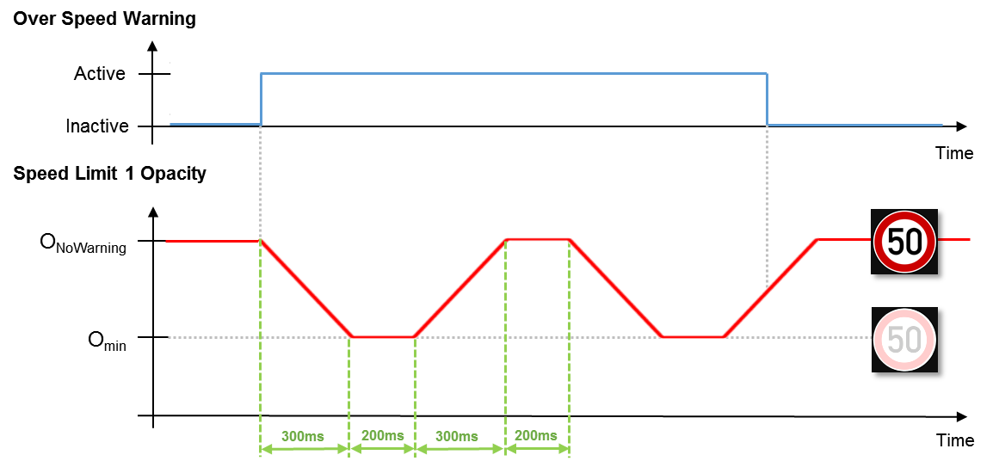
If the warning is active for more than 10 seconds, the pulsation of the speed limit shall pause for 20 seconds. This procedure (10s pulsation, 20s break) shall be repeated as long as the warning is active:
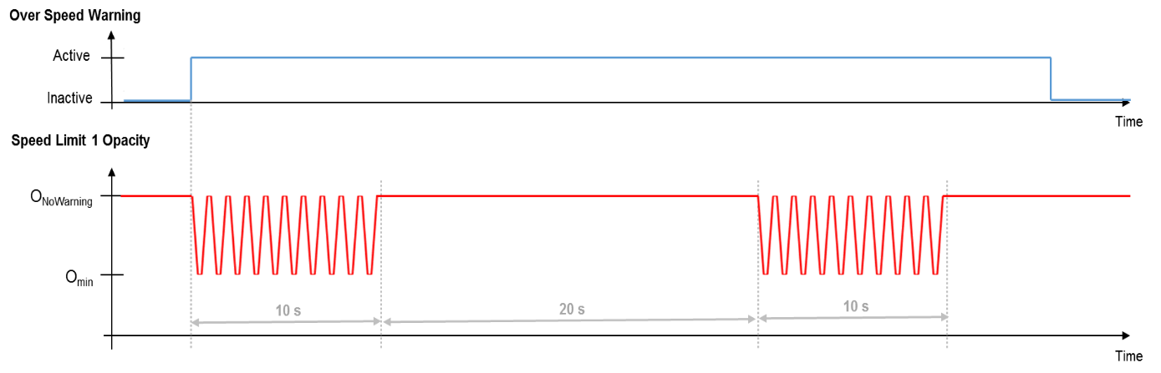

The 30s cycle (10s pulsation, 20s break) shall start from the beginning when the over speed warning is activated.
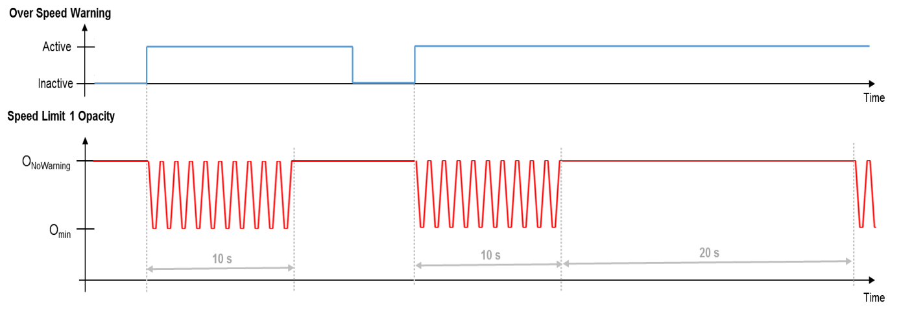

Upon detecting “TSR_OSW_Conditions = False”, the “TSR_OSW_Indication” shall be set to Inactive. Which means the current “ramping” shall be completed. If ramping up, the ramping shall be considered complete when the speed sign is at its fully defined opacity. If ramping down, the ramping shall be considered complete whne the speed sign is at its lowest defined opacity (not gray).

In case of speed limiter (ASLD) warning being active at the same time as the TSR over speed indication, the pulsation/ramping shall be synchronized to the ASLD pulsation:
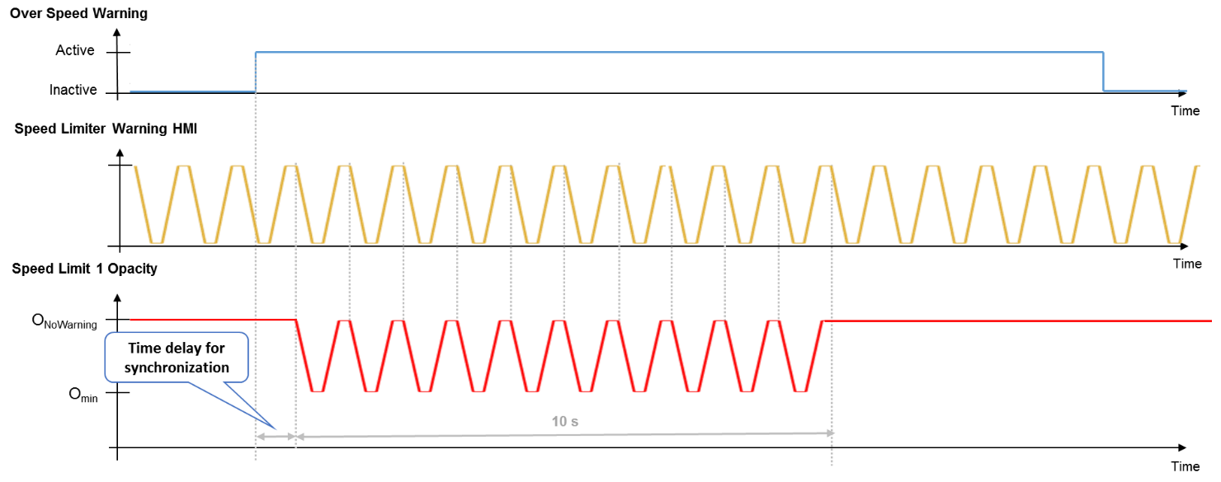

Note: If the above defined pulsation is not feasible due to component hardware limitations, the pulsation shall be replaced by a flashing between two opacities.
This exception shall be approved by the IPC D&R and TSR feature application team.

F-REQ-331943/B-State Matrix for TSR Overspeed Chime Status flag

Operational Mode | TSR_Cfg | SLIF_Cfg | Chime_Menu_  Information_Status_Flag | TsrVLim1MsgTxt_D_Rq  Signal | TsrOswWarnMsgTxt_D_Rq  Signal | TSR_OSW_CHIME_  Status_Flag  (CHIME_30)
Normal or Crank | 0x1  (Enabled) | 0x0  (Disabled) | Chime Play  (0x0) | != (0x0, 0xFB 0xFF) | 0x2 (True) | Active
All Other Cases |  |  |  |  |  | Inactive

Operation Description (supports algorithm flowchart /state diagram)

F-REQ-331858/B-TSR Indicators
There are up to two (depending on configuration) dedicated indication locations for displaying 3 TSR related icons. One location is dedicated for Speed limit 1 information. In full TSR (SLOIF) mode, the second location is shared between the No Passing Information and Speed Limit 2 information. In SLIF mode, the road sign indication is displayed in the second location. If road sign is not available, the second location is not used (no blank paceholder displayed either).

F-REQ-331859/B-Control Module
The front camera (IPMA) module controls all of the processing and arbitration of the TSR speed limit information. Hence the cluster is not required to determine if Speed Limit 2 information needs to be displayed based on Speed Limit 1. The instrument cluster is responsible for displaying the information per HMI direction.

F-REQ-331860/A-Over Speed condition on Speed Limit 1
IPMA will always transmit the higher value on speed limit 1, hence only this limit is considered for indicating over speed conditions. (logic handled in the IPMA)

F-REQ-331861/A-TSR and ASLD synchronization
In the event of TSR indication and ASLD RTT flashing at the same time, the two shall be synchronized.

F-REQ-331862/A-TSR Generic vs Detailed Indications
The TSR generic indications and the detailed indications are mutually exclusive. The indications are displayed based on the cluster display type, which is determined by the HMI team.

F-REQ-331864/A-TSR Over speed Threshold and Unit Changes
- The numerical value of the overspeed threshold shall remain constant even if TSR units are changed.
- In the case of TSR speed unit changing) the IPMA will send updated OSW thresholds to the IPC. This will ensure that the threshold ranges are not exceeded (e.g. 25 mph in SLOIF NonNCAP Mode).
- The IPC shall update the OSW values according to the IPMA’s request.
- Error values shall be displayed as 0 for threshold selection.

FS-REQ-331944/A-Function Safety Classification (EMC)
Class B

Memory Storage

NVM-REQ-331866/B-Memory Storage Parameters

Parameter Name | Description | Value at  Battery Connect | Value at  Wake-up
- TSR_OSW_THRESHOLD_MC  - TSR_No_Passing_Detail_Ind_MC  - TSR_No_Passing_Generic_Ind_MC  - TSR_Speed_Limit_1_Detail_MC  - TSR_Speed_Limit_1_Generic_MC  - TSR_Speed_Limit_2_Detail_MC  - TSR_Speed_Limit_2_Generic_MC | Output(s) displayed in the message center | Inactive | Inactive
TSR_OSW_CHIME_Status_Flag | Output chime status flag to the chime arbitrator. | Inactive | Inactive
TSR_Road_Sign_Display_MC | Output variable that displays road sign information | Inactive | Inactive
Current_PERS | Current Personality Profile | Vehicle (0x4) | Do Not Init
MsgCntrDsplyOp_D_Rq Signal | Output Signal to indicate Request Type. | NULL (0x0) | Do Not Init
MsgCntrFeatNoRq Signal | Output Signal to indicate Feature Number. | (0x0000) | Do Not Init
MsgCntrFeatConfigRq Signal | Output Signal to Specify the desired feature Value. | (0x0000) | Do Not Init
MsgCntrPersIndex_D_Rq Signal | Output Signal to indicate which personality profile is being accessed. | Vehicle (0x4) | Do Not Init
FeatNoIpmaActl Signal | Input signal sent from Ipma to indicate Feature Number. | (0x0000) | Do Not Init
FeatConfigIpmaActl Signal | Input signal sent from Ipma to indicate current value of the feature setting for the feature that is being set or queried. | (0x0000) | Do Not Init
PersIndexIpma_D_Actl Signal | Input signal sent from Ipma to indicate which personality profile is being reported. | Vehicle (0x4) | Do Not Init
Settings_Menu_Cfg | Configures cluster to display items in the Settings menu (Set to “cluster” at cluster supplier manufacturer plant) | Use Stored Value | Use Stored Value
TsrOvtkStatMsgTxt_D_Rq Signal  TsrOvtkMsgTxt_D_Rq Signal  TsrOvtkTypeMsgTxt_D_Rq Signal  TsrOvtkMsgTxt2_D_Rq Signal | Input signals sent from IPMA to process No passing information. | 0x0  0x1  0x0  0x0 | 0x0  0x1  0x0  0x0
TsrRegionTxt_D_Stat Signal | Input signal sent from IPMA that determines the graphics that need to be displayed for a specific region | 0x1 | 0x1
TsrVLim1MsgTxt_D_Rq Signal  TsrVl1StatMsgTxt_D_Rq Signal  TsrVl1RstrcMsgTxt2_D_Rq Signal  TsrVl1TypeMsgTxt_D_Rq Signal  TsrVl1PrmntMsgTxt_D_Rq Signal | Input signals sent from IPMA to process information for Speed Limit 1 displays | 0xFF  0x0  0x0  0x0  0x0 | 0xFF  0x0  0x0  0x0  0x0
TsrVLim2MsgTxt_D_Rq Signal  TsrVl2StatMsgTxt_D_Rq Signal  TsrVl2RstrcMsgTxt2_D_Rq Signal  TsrVl2TypeMsgTxt_D_Rq Signal  TsrVl2PrmntMsgTxt_D_Rq Signal | Input signals sent from IPMA to process information for Speed Limit 2 displays | 0xFF  0x0  0x0  0x0  0x0 | 0xFF  0x0  0x0  0x0  0x0
TsrVlUnitMsgTxt_D_Rq Signal | Input signal sent from IPMA to factor in the units when setting overspeed offset. | 0x1 (kmh) | Use Stored Value
TsrOswWarnMsgTxt_D_Rq Signal | Signal from IPMA to trigger the OSW indication when Digital speedo is disabled | (0x1) FALSE | (0x1) FALSE
RoadSignRgltry_D_Dsply Signal | Signal from IPMA to trigger road sign indication | 0x0  (None) | 0x0  (None)
Chime_Menu_Information_Status_Flag | Refer to “Chime Menu Control Function – CGEA1.3” STSS
TSR_Cfg | State indicator for feature presence controlled via CAN at EOL at VO plant. Set to disabled at Cluster Supplier Manufacturing Plant | Use Stored Value | Use Stored Value
SLIF_Cfg | State indicator for feature presence controlled via CAN at EOL at VO plant. Set to disabled at Cluster Supplier Manufacturing Plant | Use Stored Value | Use Stored Value
M/C_Display_Status | State Indicator to identify which text is currently being displayed on Message Center display. See * | See * | See*
M/C Switch Event | Event that is indicated as per the switch interface for the Message Center. See * | See * | See*
Operational_Mode | 4 state indicator for cluster operational mode | Limited | Limited, Normal or Crank
* Refer to Message Center X Display_Y Button Interface Section, where X and Y are appropriate values in this document.

NVM-REQ-331867/A-TSR Timers Table

Parameter Name | Description | Range | Units | Res | Init Value
OSW_Active_Timer | Time duration during which the speed limit sign ramps from highest opacity to lowest opacity to indicate over speed indication | 0-10 | sec | 1 | 10
OSW_Dormant_Timer | Time duration during which the speed limit sign stays at the lowest opacity in between two active states. | 0-20 | sec | 1 | 20

HMI-REQ-331945/B-Reconfigurable Telltale
State Matrix for TSR indication graphics based on Region
TsrRegionTxt_D_Stat | Country | Example of Traffic Sign Indications
TsrRegionTxt_D_Stat | Country | Speed Limit Signs | No Passing Active | No Passing Canceled
Region_01 (0x1) | All Other regions (not captured below) |  |    |   
Region_02 (0x2) | UK, Northern Ireland
Region_03 (0x3) | United States, Canada | 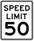 | Not Applicable | Not Applicable
Region_04 (0x4) | China
Region_05 (0x5) | Argentina, Bolivia, Brazil, Chile, Colombia, Ecuador, Falkland Islands, French Guiana, Guyana, Paraguay, Peru, Surinam, Uruguay, Venezuela |  |  | Not Applicable
0x0, 0x6-0x1E | Not Available (Feature not active)

Prove Out
Not applicable

Message Center Msg

HMI-REQ-333018/A-TSR Aging Strategy Transition
The TSR feature applies an aging strategy between “new/changed” and “reliable” speed signs. This is controlled by the ADAS ECU. The cluster shall be responsible for handling the transition by displaying a smooth transition between the “changed” and “reliable” speed indications as per HMI direction.

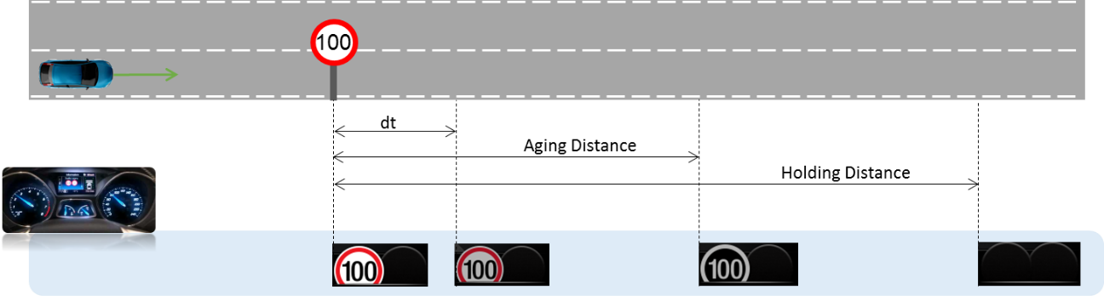

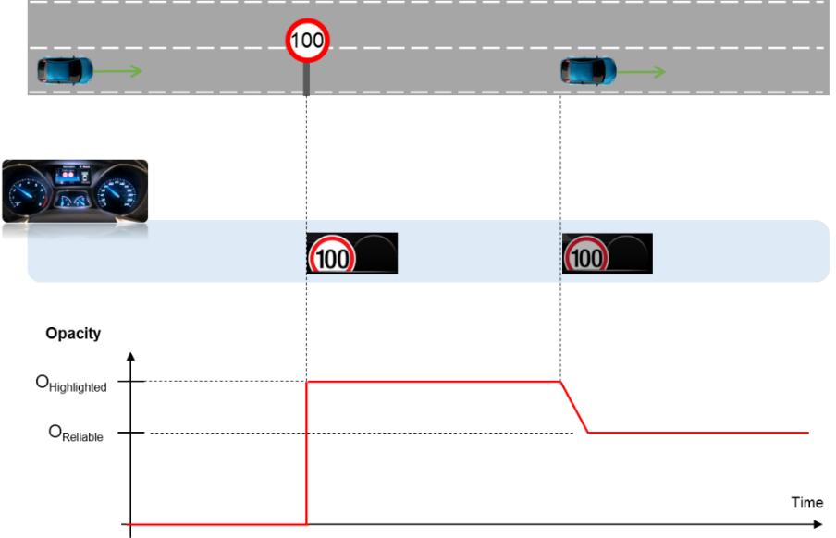

Note: This smooth transition shall be implemented only from “changed” to “reliable” speed limit information. There is no transition from “reliable” to “changed” since the speed value will be different.

Error Handling

F-REQ-331947/A-Missing Message Strategy

The signals will be declared missing as per the Diagnostics section of this SPSS.

DTCs states and history will be determined as per the Diagnostics section of this SPSS.

If TSR_Cfg = Disabled (0x0) and SLIF_Cfg = Disabled (0x0), the cluster shall never log a missing message DTC for this feature.

If a signal is declared as missing, the display shall be done as “All other cases” in the tables. The last status shall not be kept.

Diagnostics

Self Test

None

Engineering Test Mode

Reference section “Dealer / Engineering Test Mode (ETM)”

Part II Performance

DTC-REQ-331948/B-Supported Diagnostic Trouble Codes (DTCs)

DTC | Description
C23A00 | Lost Communication with IPMA (Image Processing Module “A”)
Log Invalid Data DTC if _UB associated with a CAN signal, missing message DTC otherwise.

DCR-REQ-331949/A-DID DExx

Block  Num | Block Description | Byte(s) | Bits | State: Description | "0" | "1" | Default | Comments/  Information
PACKETED BLOCKS
$02 | Option Content (B&A) | * | 1 | Traffic Sign Recognition | Disabled | Enabled | 0x0 | This option is enabled on FoE variants only.  This parameter allows the TSR settings menu to be displayed in the cluster, as well information. The settings menu can be over-ridden by the Settings Menu config.
$09 | Option Content (B&A) | * | * | Settings Menu | Cluster | Center Stack | Cluster | This parameter allows the Settings menu to be displayed in the cluster when 0x0. When 0x1, the expectation is that settings are displayed in the Centerstack. For this feature (when 0x1), the cluster will remove almost all items from settings menu. (Cluster display choices remain). Note this is a global config, each feature still has its own config for presence on vehicle.
$08 | Option Content (B&A) | * | 1 | SLIF | Disabled | Enabled | 0x0 | This parameter allows the Speed Limit Information Function (SLIF) settings menu to be displayed in the cluster, as well as information. The settings menu can be over-ridden by the Settings Menu config.
*Byte and bit location to be identified in Part II Specification for this cluster

Reference Specification
None

Revision History
SPSS Module Revision History

Revision Level | Name | Change Description | Date
1.0 | V. Patel | Initial release for FNV2 architecture. Leveraged from “Traffic Sign Recognition Control Function – CGEA1.3_v6.3” STSS  DI CC approval: 10/8/2018  Feature owner: Sepcke, Felix | 11/05/2018
1.1 | V. Patel | There is no change in feature functionality. This update fixes a few very minor spec issues along with the traditional row for “All Other Cases” in 4 tables got missed during spec development.  Updates are shown in blue.  - Added the “All Other Cases” row in the following tables:  F-REQ-331935  F-REQ-331936  F-REQ-331937  F-REQ-331938  - F-REQ-331943: Add column for TsrVLim1MsgTxt_D_Rq to match with requirements for over speed indication.  - DTC-REQ-331948: Add note below table to log invalid data DTC if CAN signal as an associated _UB signal. | 1/22/2020
2.0 | V. Patel | This update adds new indicator that displays road signs wherever applicable.  The road sign indicator shares the same space as TSR speed limit 2 and overtaking indications and so will only be displayed when those two are not active.  DI CC approval: 10/8/2020  Change Requester: Guesten, Jan  DI Spec Tracker: 621  All updates are shown in orange.  Section 1.2.1: Added RoadSignRgltry_D_Dsply as new input CAN signal and TSR_Road_Sign_Display_MC as new output.  SIG-REQ-402302: Added CAN signal details for RoadSignRgltry_D_Dsply.  IR-REQ-331798: Add TSR_Road_Sign_Display_MC to table of outputs.  F-REQ-331811: Updated flowchart to give road sign display higher priority over 2nd speed limit indication.  F-REQ-331813: Updated flowchart to give road sign display higher priority over no-passing indication.  F-REQ-331858: Added requirement to display road sign indication in the second position for SLIF.  F-REQ-402337: Added matrix to display road sign indicator.  NVM-REQ-331866: Add Init values for new CAN signal and output variable. | 11/12/2020

